Title of the manuscript
Angie A. Smith¹, B. Bradley Miller¹, Carl Carter²
¹Department example, University example, city, postal code, country
²Laboratory example, city, postal code, country
Correspondence to: Angie A. Smith (angie@email.com)
Abstract. Please use only the styles of this template (MS title, Authors, Affiliations, Correspondence, Normal for your text, and Headings 1–3). Figure 1 uses the style Caption. The abbreviation “Fig.” should be used when it appears in running text and should be followed by a number unless it comes at the beginning of a sentence, e.g.: “The results are depicted in Fig. 5. Figure 9 reveals that.” Figures and tables as well as their captions must be inserted in the main text near the location of the first mention (not appended to the end of the manuscript). Regarding colour schemes, it is important that your maps and charts allow readers with colour vision deficiencies to correctly interpret your findings. Please check your figures using the Coblis – Color Blindness Simulator and revise the colour schemes accordingly.

1 Section (as Heading 1)
Suspendisse a elit ut leo pharetra cursus sed quis diam. Nullam dapibus, ante vitae congue egestas, sem ex semper orci, vel sodales sapien nibh sed lectus. Etiam vehicula lectus quis orci ultricies dapibus. In sit amet lorem egestas, pretium sem sed, tempus lorem (Smith et al., 2014; Miller and Carter, 2015).

1.1 Subsection (as Heading 2)
Quisque cursus massa sed urna congue, ac convallis neque consectetur. Proin faucibus neque non metus mollis, suscipit pretium nisl blandit. In hac habitasse platea dictumst. Nam laoreet augue eu odio eleifend, non posuere quam pulvinar. Integer sit amet leo vitae nisl facilisis tristique.
In placerat dictum urna ut interdum. Etiam vel nibh vulputate, scelerisque purus in, congue eros. Pellentesque at nisi at nunc sagittis cursus. Mauris euismod tellus at mi tempor, sit amet finibus ante tincidunt. Aenean id ornare neque.

1.2 Subsection (as Heading 2)
Ut rutrum, sapien et vulputate molestie, augue velit consectetur lectus, bibendum porta justo odio lobortis ligula. In in urna nec arcu iaculis accumsan nec et quam. Integer ut orci mollis, varius justo vitae, pellentesque leo. Vestibulum eu finibus nisl.

1.2.1 Subsubsection (as Heading 3)
In placerat dictum urna ut interdum. Etiam vel nibh vulputate, scelerisque purus in, congue eros. Pellentesque at nisi at nunc sagittis cursus. Mauris euismod tellus at mi tempor, sit amet finibus ante tincidunt. Aenean id ornare neque. Cras ut sapien quis erat pretium ultricies.
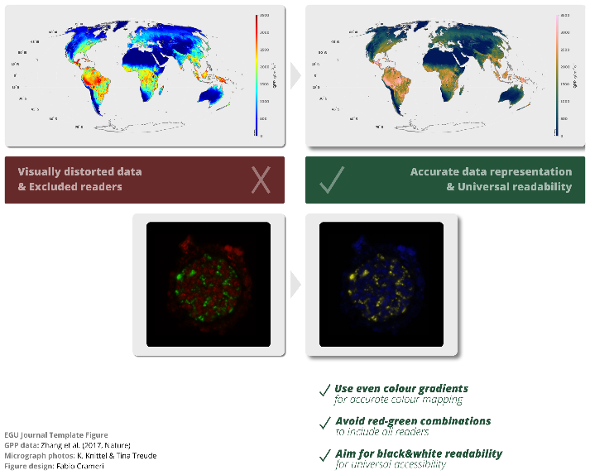
Figure 1: An example for accurate data representation & universal readability of figures.

In eget metus lorem. Fusce vitae ante dictum, elementum sem non, lacinia dui. Integer tellus tortor, convallis et aliquam non, dictum vel mauris.

1.2.2 Subsubsection (as Heading 3)
Quisque maximus mollis dui, a mollis mauris vehicula in. Duis dui ligula, suscipit ac lectus vitae, fringilla euismod diam. Suspendisse a elit ut leo pharetra cursus sed quis diam. Nullam dapibus, ante vitae congue egestas, sem ex semper orci, vel sodales sapien nibh sed lectus. Etiam vehicula lectus quis orci ultricies dapibus. In hac habitasse platea dictumst. Nam laoreet augue eu odio eleifend, non posuere quam pulvinar. Integer sit amet leo vitae nisl facilisis tristique calculated following Eq. (1):
$Y=\frac{∆M_{0}}{∆\left[\text{isoprene}\right]}$ , (1)
where $∆M_{0}$ is Ut rutrum, sapien et vulputate molestie, augue velit consectetur lectus, bibendum porta justo odio lobortis ligula. In in urna nec arcu iaculis accumsan nec et quam. Integer ut orci mollis, varius justo vitae, pellentesque leo. Pellentesque at nisi at nunc sagittis cursus. Mauris euismod tellus at mi tempor, sit amet finibus ante tincidunt. Aenean id ornare neque. Cras ut sapien quis erat pretium ultricies. Integer vulputate ante nec elementum tristique. Ut.

2 Section (as Heading 1)
Sed ullamcorper venenatis quam, ut aliquet augue iaculis quis. Mauris at elit quis magna cursus accumsan non vel nisi. Aliquam felis ipsum, interdum sed massa id, efficitur eleifend est. Pellentesque convallis, metus vel mattis molestie, ipsum diam pulvinar lorem, eget interdum urna sem et leo. In pharetra massa dictum gravida scelerisque. Sed vitae purus eget purus tincidunt accumsan ut at magna.

References
Miller, B. B. and Carter, C.: The test article, J. Sci. Res., 12, 135–147, doi:10.1234/56789, 2015.
Smith, A. A., Carter, C., and Miller, B. B.: More test articles, J. Adv. Res., 35, 13–28, doi:10.2345/67890, 2014.

